CURRICULUM MANAGEMENT

INDIVIDUAL ASSESSMENT

GROUP – 1

By Adharsh Sundaram Soudakar (23796349)

Up until this moment, I have two main technical contributions. There are several non-technical contributions (Documentation and Planning) that I have done. The technologies that I used to accomplish this were HTML, CSS, and GitHub. I worked on building the login page and the register page. All my work (technical and non-technical) can be found on [GitHub](https://github.com/qinscode/2024-CITS5206-IT-Capstone-Group-1/) with my commits.

It contains the HTML pages (login.html and register.html), the CSS that was applied to these pages (style.css) and the logo that I used while building these pages. These pages are basically forms that are well designed to look attractive.

I did not use any CSS frameworks to style the pages and did all the styling using raw CSS, it came out pretty good to be honest. I came up with a design that is very minimal and not too flashy.

These pages weren’t designed using the major technologies that are being used to build the main application as this won’t be a problem since it is very easy to convert this implementation to the required language.

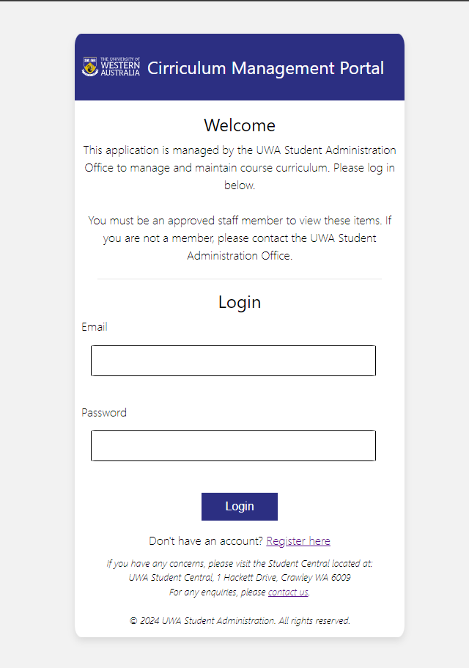 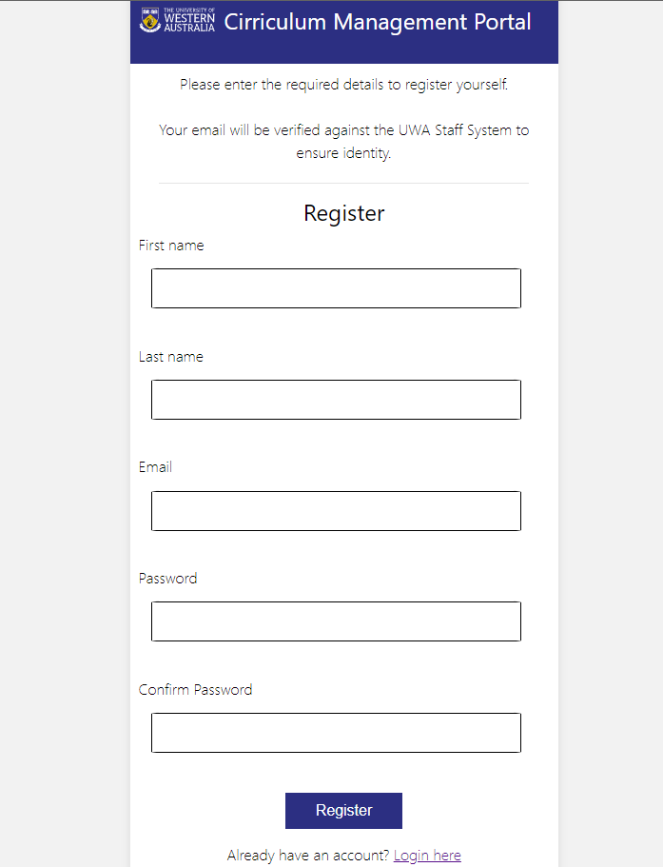

Fig. Screenshots of the login and register page.

The HTML code was validated using the [W3C Markup Validation Service](https://validator.w3.org) to ensure that the code I have implemented meets the standard and is feasible for actual deployment. Also, the CSS implementation was verified using the [W3C CSS Validation Service – Jigsaw](https://jigsaw.w3.org/css-validator/) to avoid redundancy and improper selector usage.

I ran through several design ideas on paper to see which one looks best but I am not able to attach screenshots due to page limit.

Although I don’t know if these page designs would be final (under discussion, hence under the folder prototype), this is the progress I have come up with regarding my allocated work. Even if they don’t become the final choice, they would at least have helped inspiring us to design better.

Furthermore, I closed an [issue](https://github.com/qinscode/2024-CITS5206-IT-Capstone-Group-1/issues/6) on GitHub which helped the team understand the client requirements better. Although this might not be directly technical related, this helped one of my teammates change her code so that the feature matches the requirement of the client.

Collaboratively, I helped one of the teammates with the design prototype (static pages on [Figma](https://www.figma.com/design/dSrfOm6FZ8IjLN9U8s32O3/CRMS?node-id=0-1)). This helped the whole team communicate better with the clients as pictures bring better understanding than words. This was a critical step for us, as the clients were able to see our vision and helped us correct it and align it according to their requirements.

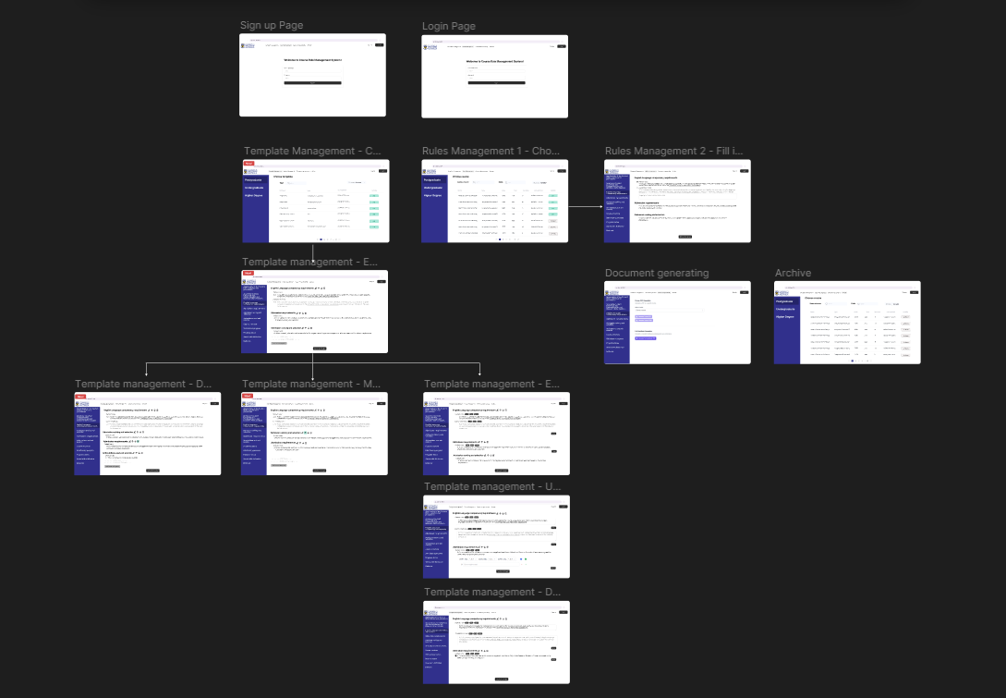

Fig. Screenshots of the design prototype.

Finally, I built 95% of our [Trello workspace](https://trello.com/b/ZE32wXCI/cits5206-capstone) and populated it with tables and cards that are well detailed with accurate and proper timeline resulting in meeting all milestones and deadlines without delay till now. This helped us deploy work at a constant and an unproblematic flow which has resulted in reaching this stage of the project with a happy client.